**Statistical Summary for City Population and Transaction Amount:**

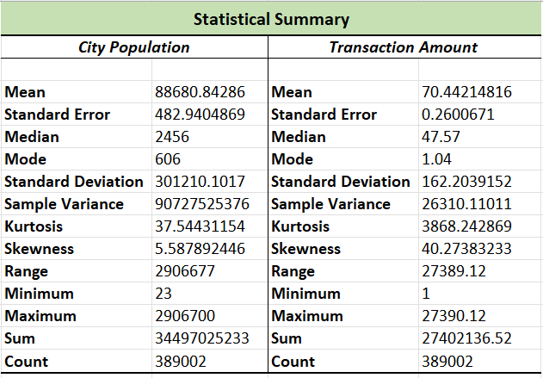

**Histogram for Transaction Amount:**

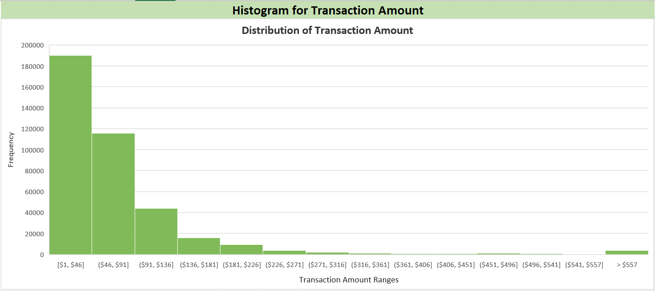

**Fraudulent Transactions by Gender and Category:**

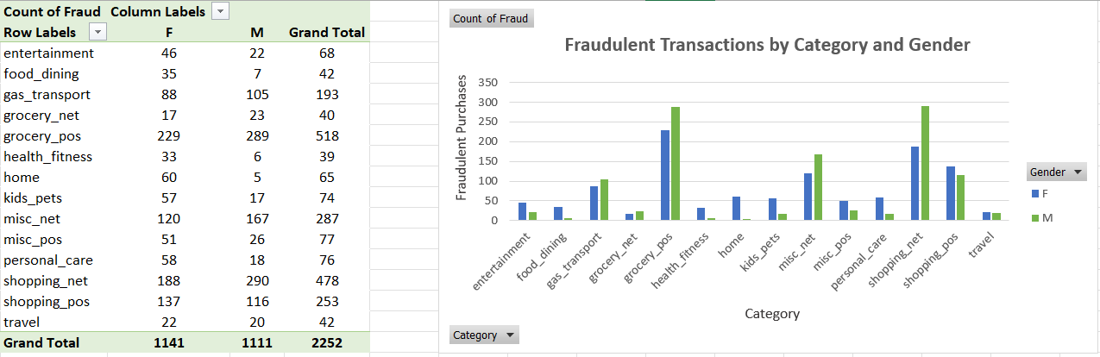

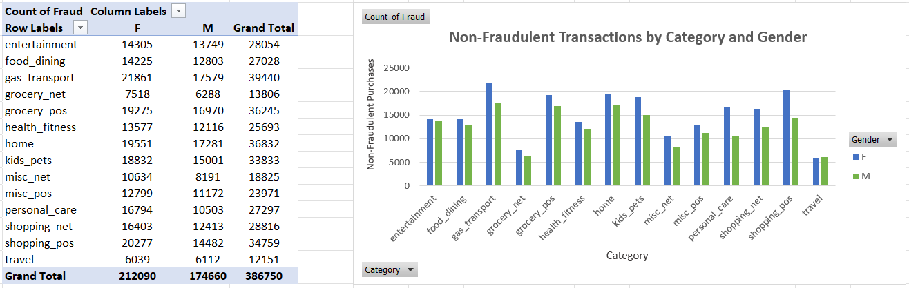

**Number of Transactions by State:**

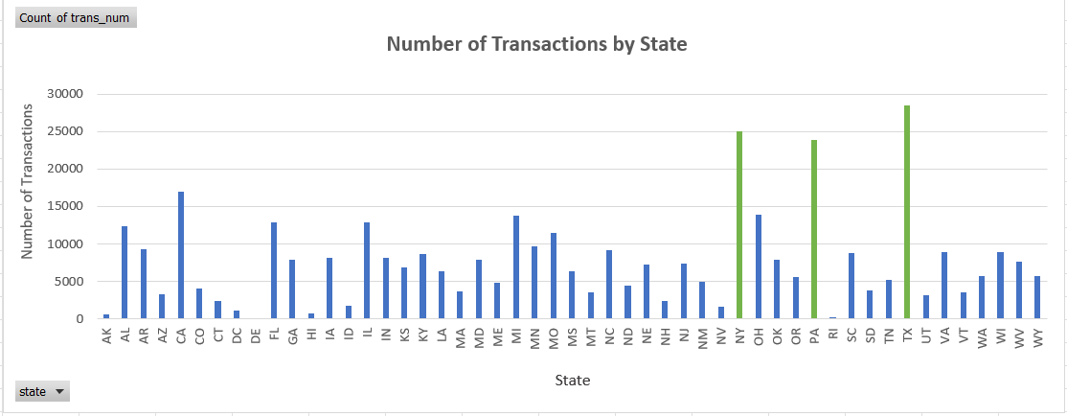

**Correlation between Transaction Amount and City Population:**

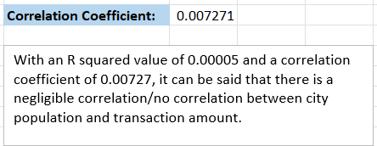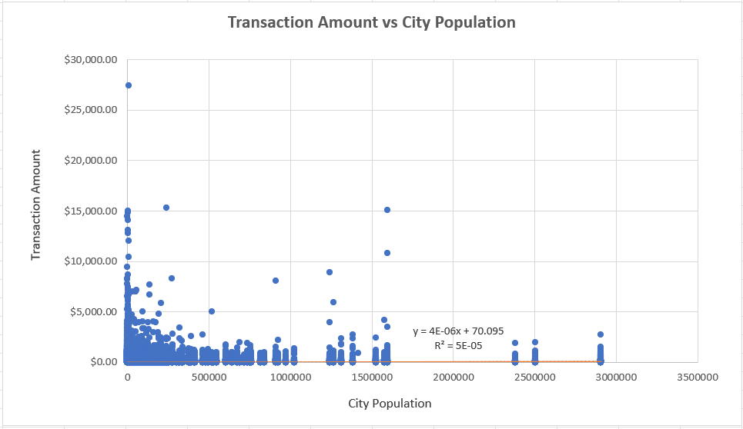

**Fraudulent Transactions by Category:**

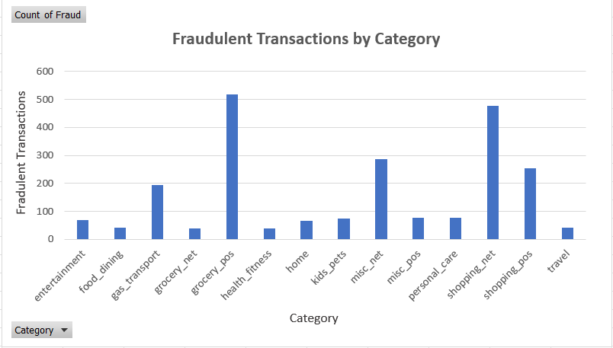

**Average Transaction Amount by Job Role:**

